When you are implementing a software as a service (SaaS) solution, you are responsible for configuring high availability.  
Instructions: Review the underlined text. If it makes the statement correct, select "No change is needed". If the statement is incorrect, select the answer choice that makes the statement correct.

* A. No change is needed.
* B. defining scalability rules
* C. installing the SaaS solution
* D**. configuring the SaaS solution**

An organization that hosts its infrastructure in a private cloud can decommission its data center.  
Instructions: Review the underlined text. If it makes the statement correct, select "No change is needed". If the statement is incorrect, select the answer choice that makes the statement correct.

* A. No change is needed.
* B. in a hybrid cloud
* **C. in the public cloud**
* D. on a Hyper-V host

**swer:** 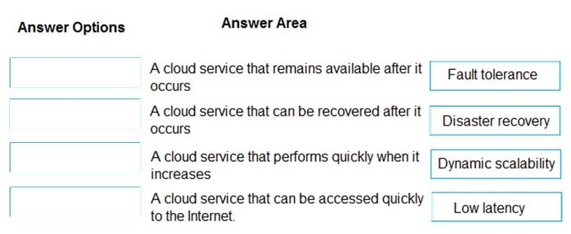

**Answer:** 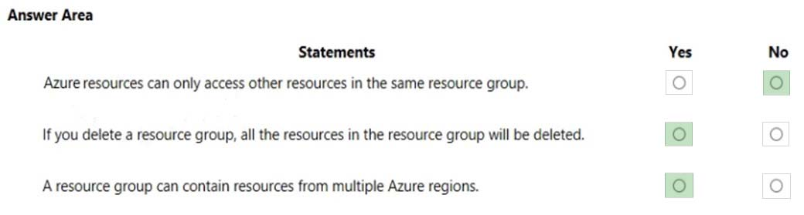

**Answer:**

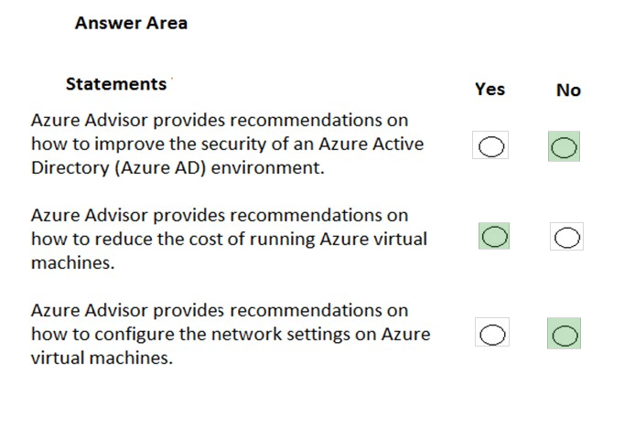

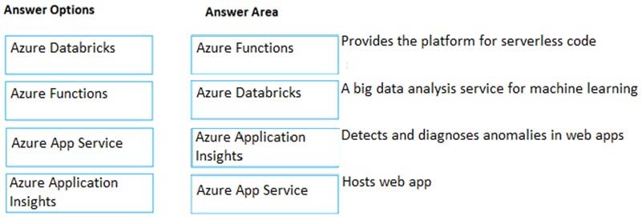

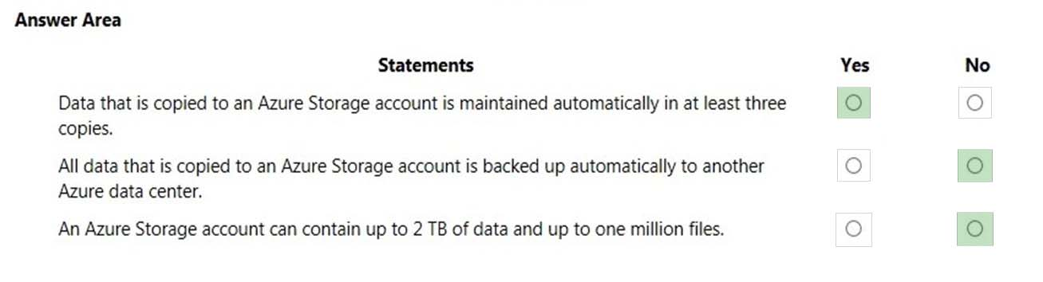

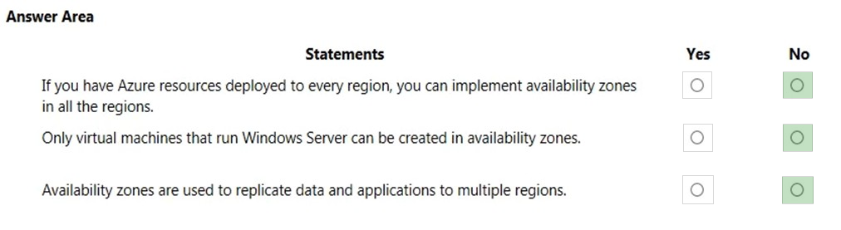

Which term from the list below would be viewed as benefits of using cloud services?  
-Unpredictable Costs  
**-Elasticity**  
-Local Reach Only

Suppose you have two types of applications: legacy applications that require specialized mainframe hardware and newer applications that can run on commodity hardware. Which cloud deployment model would be best for you?  
-Public Cloud  
-Private Cloud  
**-Hybrid Cloud**

You're developing an application and want to focus on building, testing, and deploying. You don't want to worry about managing the underlying hardware or software. Which cloud service type is best for you?  
-Infrastructure as a service (IaaS)  
**-Platform as a service (PaaS)**  
-Software as a service (SaaS)

Which of the following are benefits of cloud computing? (Select 2 answers.)  
**Cost-effective**  
Static workload, regardless of demand  
Ability to maintain your own CPUs in a data center  
**Ability to scale solution as needed**  
Pay-up-front pricing model

Which of the following is a common scenario where PaaS is leveraged?  
Migrating workloads  
Storage, backup, and recovery  
**Analytics or business intelligence**  
Website hosting

Which of the following is an advantage of using the public cloud?  
-**High scalability and agility**  
-Ability to use own equipment to meet security scenarios  
-Flexibility to run locally and in cloud  
-Complete control over security

In what scenario might you choose to utilize the hybrid cloud?  
-You require pay-as-you-go pricing  
- You don't want to be responsible for maintenance or  
updates to hardware  
-You don't want up-front CapEx costs  
-**You need to use your own equipment for compliance  
purposes**

A healthcare provider needs to store highly sensitive personal information about their patients in their cloud database. The medical data they store cannot be exposed publicly. The healthcare provider is getting ready to implement a new cloud platform to store their data. As their IT specialist, what kind of cloud do you suggest?  
Public cloud  
**Private cloud**  
Healthcare cloud  
Secure cloud

Which of the following are potential disadvantages of using a private cloud? (Select 2 answers.)  
**Upfront CapEx costs**  
Do not own equipment  
May not meet security requirements  
**Requires IT expertise in organization**  
Inability to run mobile applications

A company employs 100 computer developers. These employees are often setting up and then dismantling test and development environments as they develop. As their IT specialist, which type of cloud service should you recommend?  
PaaS  
On-premises  
**IaaS**  
SaaS

Which tab of the Azure pricing calculator will you use to put together your estimate?  
A. Estimate  
**B. Products**

Which of the following is an example of an Azure compute service?  
A. **Azure Virtual Machine**  
B. Azure Load Balancer  
C. Azure Table Storage  
D. Azure Cache for Redis

Application availability refers to what?  
A. The service level agreement of the associated resource.  
B. Whether the application supports an availability zone.  
C**. The overall time that a system is functional and working.**

Which of the following defines an Azure subscription correctly?  
A. Using Azure does not require a subscription  
B. All Azure subscriptions are always free  
**C. An Azure subscription is a logical unit of Azure services that is linked to an Azure account**  
D. An account cannot have more than one subscription

3. Billing in Azure is ______________  
A. Annually for each Azure account based on usage.  
**B. Monthly for each Azure subscription based on usage.**  
C. Monthly for each Azure account based on usage.  
D. Daily for each Azure subscription based on usage.

When should you scale out your deployment?  
A. When your application or service requires a more powerful CPU or more memory to run faster.  
**B. When you need additional virtual machines to speed up your application.**  
C. When you're using excess capacity that you don't need.  
  
Tags applied at a resource group level are propagated to resources within the resource group.  
**True**  
False

Which of the following might be a good usage of tags?  
A. Using tags to associate a cost center with resources for internal chargeback  
B. Using tags in conjunction with Azure Automation to schedule maintenance windows  
C. Using tags to store environment and department association  
**D. All of the above are good ways to use tag**

Which of the following are used to determine Azure costs for each billing period?  
A. The Azure website  
B. Number of created virtual machines  
C. The Azure pricing calculator  
**D. Usage meters**

Which of the following is a factor affecting costs?  
A. Global infrastructure  
B. **Location**  
C. Availability zone

True or False. Every region has an availability zone.  
True  
**False**

Azure Cost Management allows you to _________. **A. See historical breakdowns of what services you are spending your money on.**B. See estimates of what your services might cost if you make a change.

Which one of these is not a cost-saving solution?  
A. Deallocate virtual machines during off hours.  
B. Use Azure Reserved Virtual Machine Instances.  
**C. Load balance your virtual machines for incoming messages.**  
D. Right-size underutilized virtual machines.

Suppose you have an existing application running locally on your own server. You need additional capacity but prefer to move to Azure instead of buying upgraded on-premises hardware. Which compute option would likely give you the quickest route to getting your application running in Azure?  
A. Serverless computing  
B. Containers  
**C. Virtual machines**

Suppose you work at a startup with limited funding. Why might you prefer Azure data storage over an on-premises solution?  
A. To ensure you run on a specific brand of hardware which will let you to form a marketing partnership with that hardware vendor.  
B. The Azure pay-as-you-go billing model lets you avoid buying expensive hardware.  
**C. To get exact control over the location of your data store.**

Which of the following is true about virtual networks?  
**A. You configure virtual networks through software.**  
B. A virtual network accepts network traffic on all ports. You configure the firewall through virtual machines.  
C. Virtual networks are always reachable from the internet.

How does Azure Traffic Manager reduce latency?  
A. It chooses only the fastest networks between endpoints.  
B. It chooses the endpoint that's closest to the user's DNS server.  
**C. It caches content, similar to how content delivery networks work.**

What is network latency?  
A. The amount of data that can fit on the connection.  
**B. The distance data must travel to reach its destination.**C. The time it takes for data to travel over the network

Cloud security is a shared responsibility between you and your cloud provider. Which category of cloud services requires the greatest security effort on your part?  
**A. Infrastructure as a service (IaaS)**B. Platform as a service (PaaS)  
C. Software as a service (SaaS)

Which of these helps you most easily disable an account when an employee leaves your company?  
A. Enforce multi-factor authentication (MFA)  
B. Monitor sign-on attempts  
**C. Enable Single Signon**

Which of the following would be good to put a resource lock on?  
**A. An ExpressRoute circuit with connectivity back to your on-premises network**B. A non-production virtual machine used to test occasional application builds  
C. A storage account used to temporarily store images processed in a development environment

True or False. You can select the specific datacenter you want to deploy your app into.  
True  
**False**

Imagine that you work on a photo-sharing application that runs on millions of mobile devices. Demand is unpredictable because you see a spike in usage whenever a locally or nationally significant event occurs. Which Azure compute resource is the best match for this workload?  
**A. Serverless computing**  
B. Containers  
C. Virtual machines

Which of the following situations would yield the most benefits from relocating an on-premises data store to Azure?  
**A. Unpredictable storage demand that increases and decreases multiple times throughout the year.**  
B. Long-term, steady growth in storage demand.  
C. Consistent, unchanging storage demand.

A company wants to try out some services which are being offered by Microsoft Azure in Public Preview. Do the services in Public Preview within Azure come with an SLA?

**YES**

NO

A company wants to try out some services which are being offered by Microsoft Azure in Public Preview. Does Microsoft provide a separate Azure portal for trying out the services in Public Preview?

**YES**

NO

A company wants to try out some services which are being offered by Microsoft Azure in Private Preview. Does Microsoft provide a separate Azure portal for trying out the services in Private Preview?

YES

**NO**

A company is planning on setting up a solution in Microsoft Azure.

The solution would have the following key requirement:

- A tool that provides guidance and recommendations to improve an Azure environment

Which of the following would be best suited for this requirement?

**Azure Advisor**

A company is planning on deploying resources to Microsoft Azure.  
Which of the following in Azure provides a common platform for deploying objects to the Azure Cloud Infrastructure and also allows implementing consistency across the environment?

**Azure Resource Manager**

A company is currently planning on deploying resources to Microsoft Azure.

They want to have the ability to manage the compliance of resources across multiple subscriptions.

Which of the following can help you achieve this requirement?

**Management Group**

A company needs to deploy several Virtual Machines (VMs).

Each of these Virtual Machines (VMs) will have the same set of permissions.

To minimize the administrative overhead, in which method would you deploy the Azure Virtual Machines?

**Azure Resource Manager**

<https://www.examtopics.com/exams/microsoft/az-900/view/5/>

<https://quizlet.com/391916819/azure-test-flash-cards/>

<https://www.testpreptraining.com/microsoft-azure-fundamentals-az-900-free-practice-test>